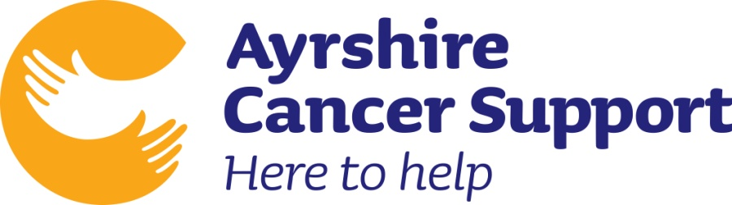
Run Roon the Toon

Head Office: 5 Dundonald Road, Kilmarnock,
Ayrshire, KA1 1EQ, Tele: 01563 538008

________________________
will be fundraising for Ayrshire Cancer Support by “Running Roon The Toon” – a challenging 10K road race round Kilmarnock, on Sunday 11th June 2017.
Please support ___________ in their efforts and raise funds for this great cause.

Help us to reclaim 25p for every £1 donated. Please tick the gift aid column to declare that you are a taxpayer and would like all donations you make to Ayrshire Cancer Support to be treated as gift aid and for the charity to benefit by claiming the tax.

PLEASE PRINT YOUR DETAILS (ALL PARTS OF THE SPONSOR SHEET FORM MUST BE COMPLETED IN ORDER FOR US TO CLAIM GIFTAID)

THANK YOU
Title  Mr/Mrs/Ms etc |  | Address  (We need your HOME address & POST CODE to claim gift aid) | Gift Aid | Amount donated | Paid

